ITEM NO | PICTURE | PRICING | MIN ORDER | SPECIFICATION DETAILS
FY-WP150A | 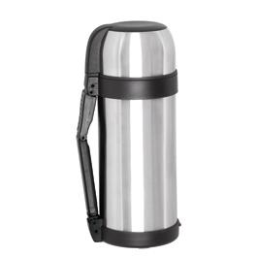 | FOB NINGBO  $4.35 | 3000PCS | CAPACITY:1500ML  PACKIGN:12PCS  N.W:12KGS  G.W:14.5KGS  MEAS:49*37*33.6CM
FY-VP250 | 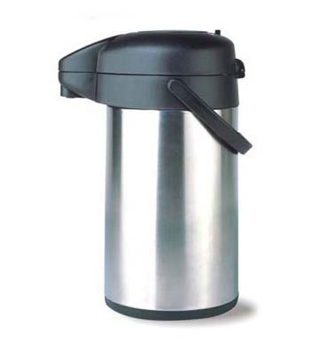 | FOB NINGBO  $10 | 3000PCS | CAPACITY:2500ml  PACKIGN:6PCS  N.W:10.9KGS  G.W:15.2KGS  MEAS:62*42*41CM
FY-6050 | 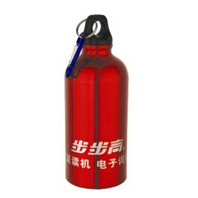 | FOB NINGBO  $ 0.68 | 3000PCS | CAPACITY:400ML  PACKIGN:48PCS  N.W:7KGS  G.W:8KGS  MEAS:63*47*22CM
FY-6100 | 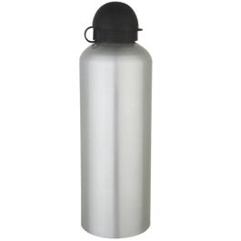 | FOB NINGBO  $0.93 | 3000PCS | CAPACITY:1000ML  PACKIGN:48PCS  N.W:11KGS  G.W:12KGS  MEAS:65*49*30CM
FY-6014 | 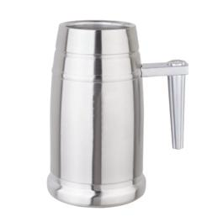 | FOB NINGBO  $1.97 | 3000PCS | CAPACITY:500ML  PACKIGN:20PCS  N.W:7KGS  G.W:9KGS  MEAS:56.5*29.5*39CM
FY-6007 | 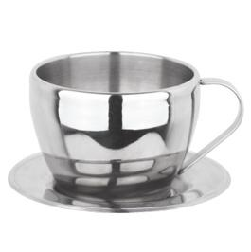 | FOB NINGBO  $0.99 | 3000PCS | CAPACITY:100ML  PACKIGN:60PCS  N.W:6.4KGS  G.W:10.5KGS  MEAS:57*46*20CM
FY-6008 | 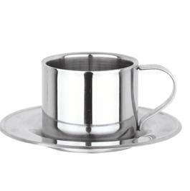 | FOB NINGBO  $0.99 | 3000PCS | CAPACITY:100ML  PACKIGN:60PCS  N.W:6.4KGS  G.W:8.8KGS  MEAS:57*46*20CM

ITEM NO | PICTURE | PRICING | MIN ORDER | SPECIFICATION DETAILS
FY-VF100 | 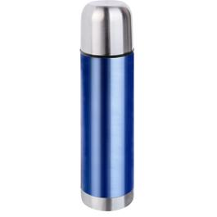 | FOB NINGBO  $2.15 | 3000PCS | CAPACITY:1000ML  PACKIGN:50PCS  N.W:12KGS  G.W:14KGS  MEAS:46*37.2*36CM
FY-VG100 | 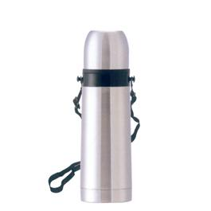 | FOB NINGBO  $2.49 | 3000PCS | CAPACITY:1000ML  PACKIGN:50PCS  N.W:12KGS  G.W:14KGS  MEAS:46*37.2*36CM
FY-012 | 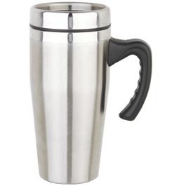 | FOB NINGBO  $1.31 | 3000PCS | CAPACITY:18OZ  PACKIGN:24PCS  N.W:7.5KGS  G.W:9.5KGS  MEAS:41*34*40CM
FY-CP100A | 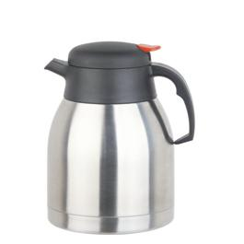 | FOB NINGBO  $3.95 | 3000PCS | CAPACITY:1000ml  PACKIGN:12PCS  N.W:9KGS  G.W:11KGS  MEAS:59.8*45.1*21.3CM
FY-CP120B | 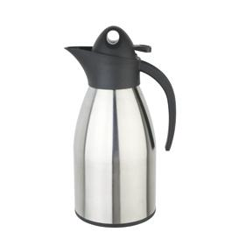 | FOB NINGBO  $3.95 | 3000PCS | CAPACITY:1200ml  PACKIGN:12PCS  N.W:7KGS  G.W:9KGS  MEAS:60*45*24CM

